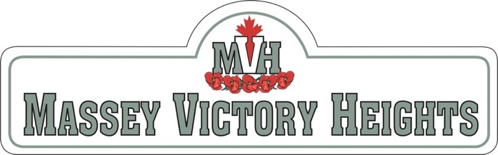
MVHRA 2024 Grant Application
To host a Block Party
Grants of $150 each will be awarded to up to 5 successful applicants per year [one per street]
- Who will organize/host this block party?
First Last Name: Click here to enter text.
Street Address: Click here to enter text.
Contact Phone Number: Click here to enter text.
- Where will it take place? i.e. Street Address[s]: Click here to enter text.
Date of Event: Click here to enter a date.
- How do you hope to use the grant? (Check all that apply)
☐ Toward the cost of food
☐ Toward the cost of furnishings:
☐ Rental of tables and chairs
☐ Rental of barricades
☐ Other Specify Here
- Send your completed application to: president@masseyvictoryheights.com

- After the event, please send a brief report to: president@masseyvictoryheights.com
Include:
  - attendance numbers
  - how the grant was spent
  - at least one photo for our web site
  - any other details you wish to share

NOTE: Cheques will be issued once report is received after the event.

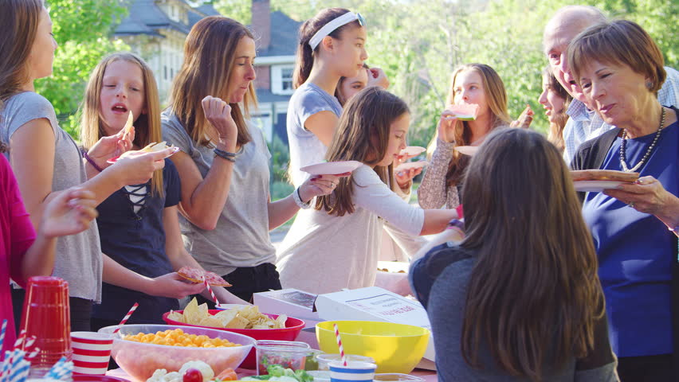

8 steps to planning your block party
- Step #1: Pick a date for your block party well in advance. ...
- Step #2: Apply for your permit. ...
- Step #3: Get some help. ...
- Step #4: Set your budget. ...
- Step #5: Define your boundaries. ...
- Step #6: Choose your entertainment. ...
- Step #7: Figure out your food situation. ...
- Step #8: Send out invites.

Read more at:

Street Closure Process: https://www.newwestcity.ca/block-parties

8 Steps to a Perfect Street Party: https://www.moving.com/tips/how-to-throw-the-perfect-block-party/

